Automated Cell Identification (ACI) in Photonic Crystal Fibers using MATLAB

An Independent Study Submitted to the Faculty of
The Department of Electrical and Computer Engineering Villanova University

By

Nicholas A. Florio

In Partial Fulfillment
of the Requirements for the Degree of Master of Science in Electrical Engineering


May 11, 2021

Independent Study Approval Form, with approving signatures

Acknowledgement

Abstract

Contents
Automated Cell Identification (ACI) in Photonic Crystal Fibers using MATLAB 1
Nicholas A. Florio 1
1. Introduction 6
2. Approaches to Filtering Microscopy Images of Cells 6
2.1 Basic Cell Counting and Segmentation in MATLAB | Pedro Segmentation 6
Figure ##: Pedro Segmentation Progression 6
2.2 Image Segmenter App 7
2.3 Granulometry | Granulometry of Snowflakes 7
Figure ##: Snowflake Granulometry Progression 7
2.4 Edge Detection | Detect Cell Using Edge Detection and Morphology 8
Figure ##: Edge Detection Progression 8
3. Integration & Results 8
3.1 Pedro Segmentation 9
3.1.1 Sample Code Verification | BasicCellSegm_PedroFoundational 9
Figure #.#: Comparison of Example Code Results to BasicCellSegm_PedroFoundational 9
3.1.2 PNAS Images Implementation 9
Figure #.#: pnasimage1 Implementation 10
Figure #: pnasimage2 Implementation 10
Figure #: pnasimage3 Implementation 11
Figure #: pnasimage4 Implementation 11
3.1.3 pnasimage1-focused Experimentation 11
3.2 Other 11
3.2.1 Image Segmenter App 11
3.2.2 Granulometry 11
3.2.3 Edge Detection 11
3.2.4 Wynne Lab Image Enhancement 11
4. Recommendations & Discussion 11
5. Conclusions 11

Table of Contents

Introduction
Introduce the topic at hand
Cell Imaging and Microfluidics/Microscopy
Approach: Filtering Microscopy Images of Cells

Approaches to Filtering Microscopy Images of Cells
After searching through multiple resources for relevant approaches to address this imaging challenge, four were selected to be tested: basic morphological with watershed, the Image Segmenter App, granulometry, and edge detection. <make a chart comparing all 4 approaches, and insert after this opening>

2.1 Basic Cell Counting and Segmentation in MATLAB | Pedro Segmentation
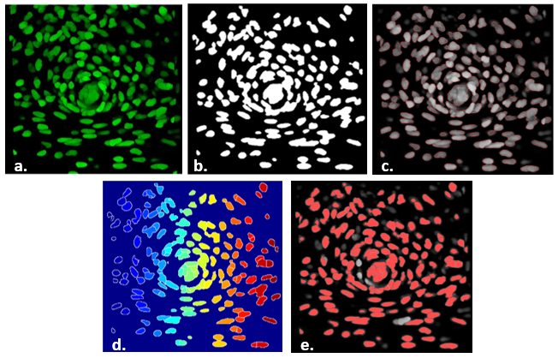
Figure ##: Pedro Segmentation Progression a. b. c. d. e.
The basic morphological with watershed approach was sourced from a "Basic Cell Counting and Segmentation in Matlab" Guide which utilizes an in vivo cell image [cite Pedro][cite his reference image paper]. The code can be split into three sections: preparation, morphological, and watershed counting. In preparation, the image is converted to grayscale, multiple filters are applied to remove noise, and contrast adjustments are made to enhance cells that appear dimmer. The morphological section involves identifying the perimeters of individual cells and/or cell groups, finding the global image threshold through Otsu's method, and binarizing the image. Since the cells had internal contrast variations, image regions and holes were filled. A morphological opening of the image is then performed and a disk-shaped structuring element is constructed which helps to further eliminate any unwanted or erroneous connected cell structures. This is followed by overlaying the greyscale, filtered, and binarized images which obtain an image of cells and cell groups being identified with a red outline. Although the code can capture most of the cells, there will not be an accurate counting of grouped cells and therefore a watershed algorithm is used. The watershed enables the user to separate the groups into individual cells to an extent. Then, the algorithm is able to translate the level/intensity of pixels as an altitude of a relief. In doing so, the user then has to adjust the image to ensure that the cell "walls" feature the greatest pixel intensity. In what would be characterized as the highly-intense cell nucleus, such maximums are downgraded to local minima, allowing for the walls to take precedence in pixel intensity. Once the watershed is fully applied, the cells can be detected, counted, and masked to an overlay of the original image to validate identifications. This was the preferred approach and one that was built upon for further testing and application for this research project's uses. See Section #.# for the further work completed with this scripting option.

2.2 Image Segmenter App
Utilizing the Image Segmenter App is a much more hands-on approach. It is either executed in the Apps tab or initiated in a script after reading an image. With the read image loaded, a user can toggle the type of threshold applied and its sensitivity as well as finding circles through entering diameters and sensitivity. One may describe the Image Segmenter App as the manual breakdown of what the previously discussed morphological code performs.

<Need to include test images from Pedro implemented into this app, and demonstrate different sensitivities with figures>

While it can be a useful tool to cross-reference what the automated algorithms of the first approach outputs, this ultimately would not satisfy the goal of a seamlessly automated and interfaced script.

2.3 Granulometry | Granulometry of Snowflakes
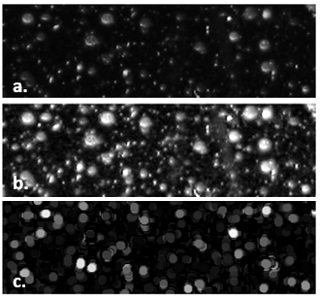
Figure ##: Snowflake Granulometry Progression - a. b. c.
The granulometry path had looked initially promising through the MATLAB "Granulometry of Snowflakes" example. Unlike the previous two approaches, granulometry finds the object size distribution in a given image, without having to first detect each individual object. This is done by first maximizing the intensity contrast of the image through a "contrast-limited adaptive histogram equalization" function known as adapthisteq. The intensity surface area (ISA) distribution is then estimated through use of a structuring element (the same disk used in the first approach) that increases in size and counts the remaining ISA after every new element is applied. One can think of granulometry "seeing" the image objects as diversely-sized rocks and then using sifts of increasing sizes to sort them. From there, the code takes the first derivative of the size distribution and then is able to extract objects with a specified radius. One can see in Figure ## how the darkened image of snowflake granules, became an image of clusters of dots, with desired ones whited-out.

2.4 Edge Detection | Detect Cell Using Edge Detection and Morphology
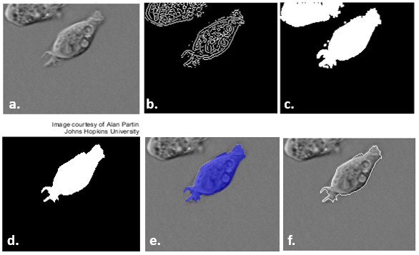
Figure ##: Edge Detection Progression – a. b. c. d. e. f.
The fourth approach using edge detection combined techniques from the previous three options. A Sobel operator was used in parallel with the edge function to find the threshold value. In short, Sobel institutes a gradient matrix for each pixel in the image. Values are compared for the x and y planes, and the higher the difference, the more likely an edge occurs at that pixel location. With Sobel completed, a binary mask is applied to observe the contrast difference of the image. Then, the cell of interest is filled ("whited-out"), the border is cleared of any straying foreign objects, and the fill is smoothed with a diamond structuring element. Finally, the smoothed mask is overlayed with the original image or an outline is drawn around the cell in the original image utilizing the data from the smoothed mask. <insert images from original to filled, to mask over and outline option>

The Wiener filter, er type utilizes that will "smooth"

It was suggested that a possible problem was the filtered image that is returned as a numerical array, was not the same size as the original input image. This was quickly dismissed however, as the arrays were verified as being the same size.

Integration & Results
As mentioned previously in Sec. #.#, the goal was to progressively adjust the scripts as necessary to identify cells of three different images; first the original image, then a PNAS image, and finally an image from Dr. Wynne’s laboratory. By doing so, repeatability would verify the success of such code. * Save for other part…Since Pedro’s segmentation code was the foundational code of choice, there were several variations based off of it

3.1 Pedro Segmentation

3.1.1 Sample Code Verification | BasicCellSegm_PedroFoundational
The intial sample code was written in the “BasicCellSegm_PedroFoundational” script and tested. Since the original image size varied by browser download and screen size, it was not fully identical to the one used in [cite Pedro]. The only effect such a deviation had on the validation was the effective number of cells counted by the algorithm. There were 199 cells counted instead of 185 cells, and thus some clusters might have been over-segmented. As seen in Figure ##.## below, it was valid to declare the sample code as functional. It should be noted that even in [], not all visible cells were identified. It is certainly not a perfect algorithm, but one to build upon.
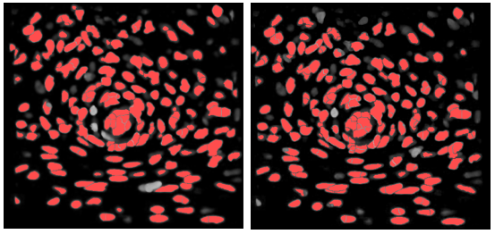
Figure #.#: Comparison of Example Code Results to BasicCellSegm_PedroFoundational – Left: Pedro Example Right: BasicCellSegm_PedroFoundational

3.1.2 PNAS Images Implementation
The next step was implementing select images from [cite PNAS paper]. As one will observe in the below figures, images with different variations of cell sizes, shapes, and contrasts were chosen to help fine-tune the algorithm. Pedro’s Segmentation code was optimized for one sample image, and when other images were tested with it, the identification success rate was mixed. Interesting observations were made with the following four images selected from [].
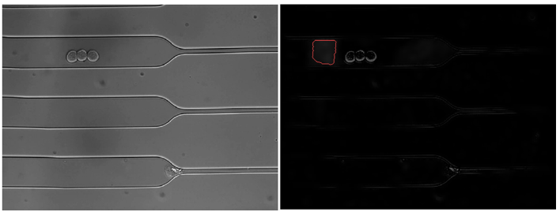

Figure #.#: pnasimage1 Implementation

Pedro’s segmentation failed to identify any of the cells in pnasimage1, and instead circled a boxed shadow next to the well-defined cluster of three cells as seen above in Fig. #. Further work was performed on pnasimage1 in Section #.#.
The code’s performance improved with pnasimage2 and it was able to differentiate between the clusters of cells for the most part as seen below in Figure #. Since the cells were illuminated a neon green color that paralleled the original sample image coloration, it was likely the detections might be more successful. For part a of pnasimage2, the large clump outlines were correctly detected with some variation while the grayer cells were missed. This detection performance was relatively consistent for parts b and c. In some cases, grayer cells had only their “nucleus” identified since the walls did not contrast the black background enough.
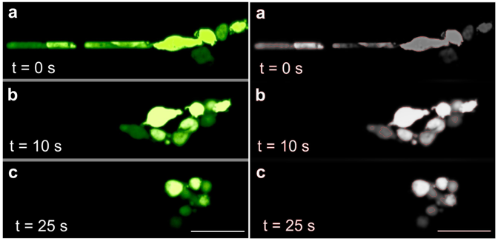

Figure #: pnasimage2 Implementation

Despite the relative success with pnasimage2, the script’s detection failed to mark any significant cells in pnasimage3 and pnasimage4. In pnasimage3, mostly shadow clumps were detected. A half-crescent identification in the right middle segment of figure #, was the closest the program was to detecting a full cell.
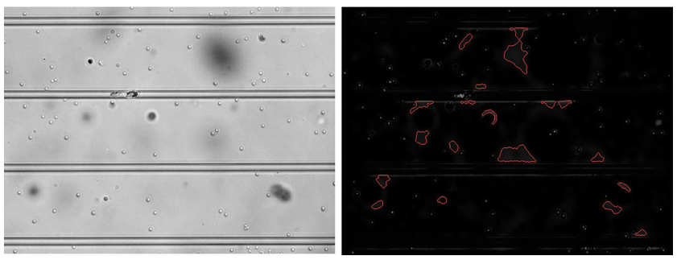

Figure #: pnasimage3 Implementation

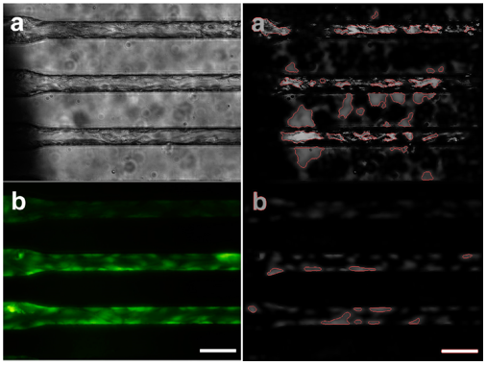

Figure #: pnasimage4 Implementation

3.1.3 pnasimage1-focused Experimentation

3.2 Other

3.2.1 Image Segmenter App

3.2.2 Granulometry

3.2.3 Edge Detection

3.2.4 Wynne Lab Image Enhancement

Recommendations & Discussion

Conclusions

